REQUESTING AUTHORITY
This service allows an individual person or an organisation that doesn't already have an authority over an entity to request authority. Having authority will enable the individual or organisation to edit the corporate information and submit filings on behalf of the company.
- Go to www.cipa.co.bw and log onto the OBRS.
- Search for and click on the company that you wish to request authority over.
- Click on FILINGS AND MAINTENANCE.
- Click on REQUEST AUTHORITY.
- Select whether you are requesting Authority as a Director of the company or as an Agent of the company.
- If requesting Authority as a director, select your details from the drop-down menu. Your profile details must match those provided for the director of the company. The system will automatically grant you Authority.
- If requesting Authority as an Agent, you will need to upload a Resolution from the company. Your request will create a task for CIPA to review, and a response will be given within 24 hours.
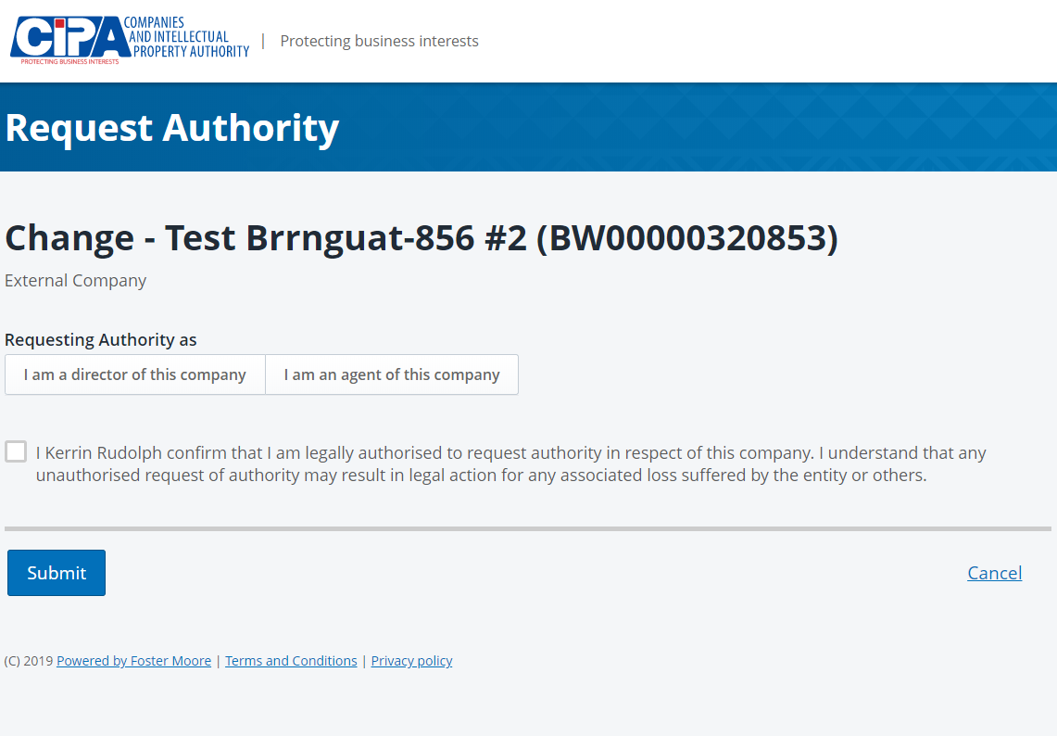

- Tick the declaration box to confirm that you are authorised to request Authority and click SUBMIT.

GRANTING AUTHORITY TO OTHERS
Authority over an entity can also be granted to an individual or organisation by another authorised user such as a Director of the company.
- Select the company from the Dashboard.
- Click on FILINGS AND MAINTENANCE
- Click on MANAGE AUTHORITY
- Click on GRANT AUTHORITY
- Select the type of authority being granted (Director, individual agent or organisation agent) and the email address of the person/organisation who authority is being granted to. Activation instructions will be sent to the entered email address. On receipt of the activation instructions the recipient will have to login and activate authority via "Accept Authority Invite". This must be done within 5 working days, failing which the invitation will expire.

REVOKING AUTHORITY
Authority over an entity can also be REVOKED by an authorised user such as a Director of the company.
- Select the company from the Dashboard.
- Click on FILINGS AND MAINTENANCE
- Click on MANAGE AUTHORITY
- Click on REVOKE AUTHORITY by the name of the person or organisation whose authority you wish to revoke.
The person/organisation will no longer have authority to make changes or submit filings on behalf of the company.

