How to Change Principal Place of Business and Registered Office Address
This service allows you to update the registered address for a company, which include physical address, postal address, principal place of business and email and phone number details. Please note that only authorised users can make changes.
- Visit www.cipa.co.bw and log onto the OBRS.
- On your Portfolio on your dashboard click on the Company whose details you wish to change.
- Click on Addresses (to the left).
- Click on Edit Details (to the right) and select MAINTAIN REGISTERED OFFICE ADDRESS AND PRINCIPAL PLACE OF BUSINESS DETAILS.
- Read the BEFORE YOU BEGIN information and click CONTINUE.
- Click EDIT on the section you wish to change and make the required changes.
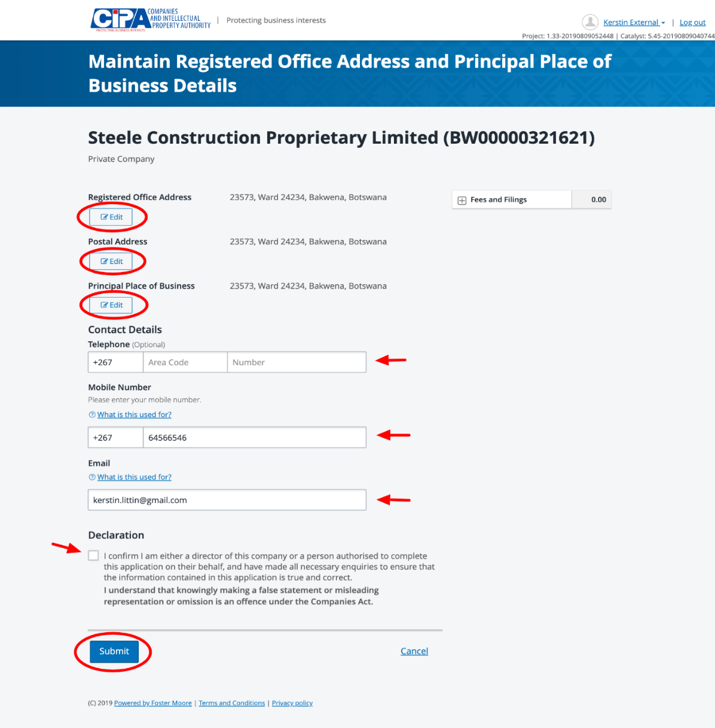
- Tick the declaration box to confirm that you are authorised to make the changes and submit. Your changes will automatically update the Register.

