HOW TO LODGE A TRANSFER OF SHARES
This service allows a user to submit a transfer of shares to the Registrar where shares are transferred between Shareholders.

You need to complete, scan and upload Form 14: Notice of Transfer of Shares of a Company, which can be found on the website under Quick Links/Forms and Downloads. In case of new shareholders, a Shareholder’s Consent Form for an Existing Company must also be completed.

- Log onto www.cipa.co.bw and select the company from the dashboard.
- Click on FILING AND MAINTENANCE.
- Click LODGE GENERAL DOCUMENT.
- Under SELECT DOCUMENT TYPE, select Transfer of Shares.
- Upload the Documents below as a single upload.
- Form 14: Notice of Transfer of Shares
- Copy of the extract from the share register
- Proof of ID of the newly appointed shareholder/s
- signed consent form of any newly appointed shareholders
- Enter an effective Date.
- Click SUBMIT.

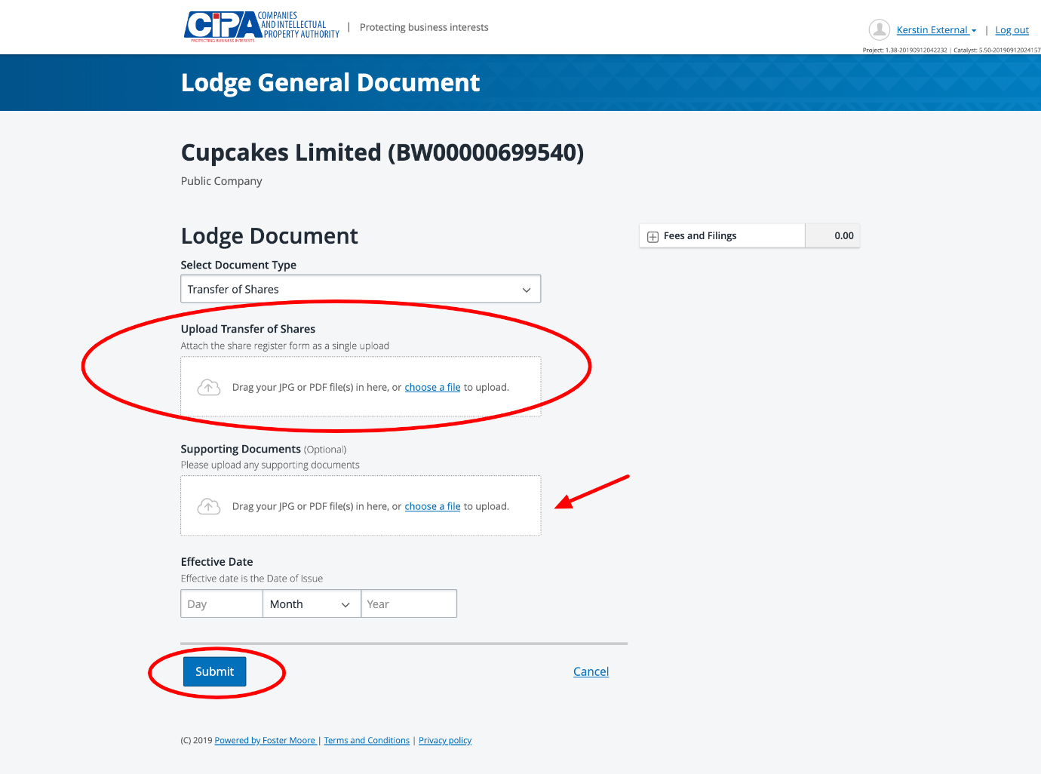

The submission will be sent to CIPA for Review. Once you receive approval, your corporate information will be updated within 24 hours.

