HOW TO LODGE AN ACQUISITION OR REDEMPTION OF SHARES
This service allows you to submit to the Registrar a Notice of Acquisition or Redemption of shares for an entity you have authority over.
The company may buy back some of their shares from existing shareholder(s) or redeem some of the shares from existing shareholder(s).
You need to complete, scan and upload Form 15: Notice of Acquisition by Company of Own Shares or Redemption of Shares, which can be found on the website under Quick Links/Forms and Downloads.

- Log onto www.cipa.co.bw and select the company from the dashboard.
- Click on FILING AND MAINTENANCE.
- Click LODGE GENERAL DOCUMENT.
- Under SELECT DOCUMENT TYPE, select Acquisition or Redemption of Shares.
- Upload the Form and any supporting document.
- Enter an effective Date.
- Click SUBMIT.
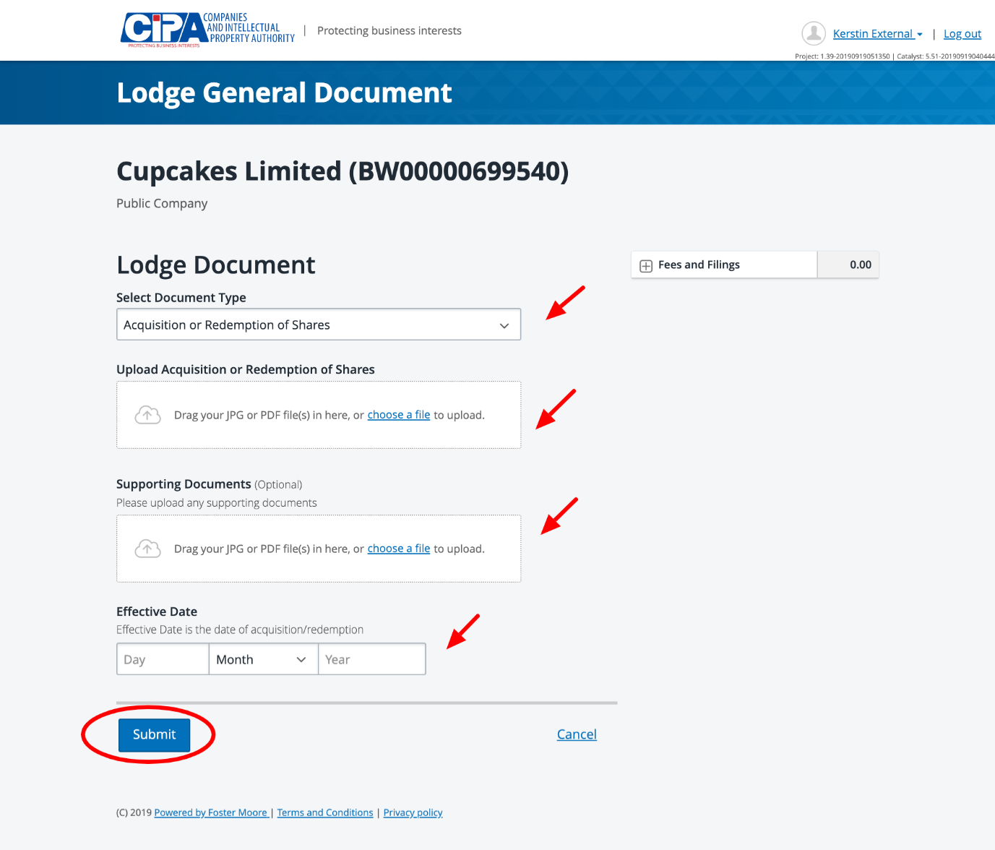

Your filing will be sent to CIPA for review. Your corporate information will be updated within 24 hours of the filing being approved.

