HOW TO MAINTAIN DIRECTOR DETAILS
This service allows changes to the Director details of a Company to be made. Existing Director’s details can be updated, existing Directors can be ceased and new Directors can be appointed. Please note that only authorised users can make changes.
- Visit www.cipa.co.bw and log onto the OBRS.
- On your Portfolio on your dashboard click on the Company whose details you wish to change.
- Click on the Directors tab (to the left).
- Click on EDIT DETAILS (to the right).
- Select MAINTAIN DIRECTOR DETAILS FOR A LOCAL COMPANY.
- Read the BEFORE YOU BEGIN information and click CONTINUE.
- If you wish to remove a Director, click CEASE. If you only wish to edit a Director’s information click EDIT. If you wish to add a new Director, click on ADD A NEW DIRECTOR. When adding a new Director, you will need to upload a Director’s Consent Form which can be found on the website under Quick Links/Forms and Downloads.
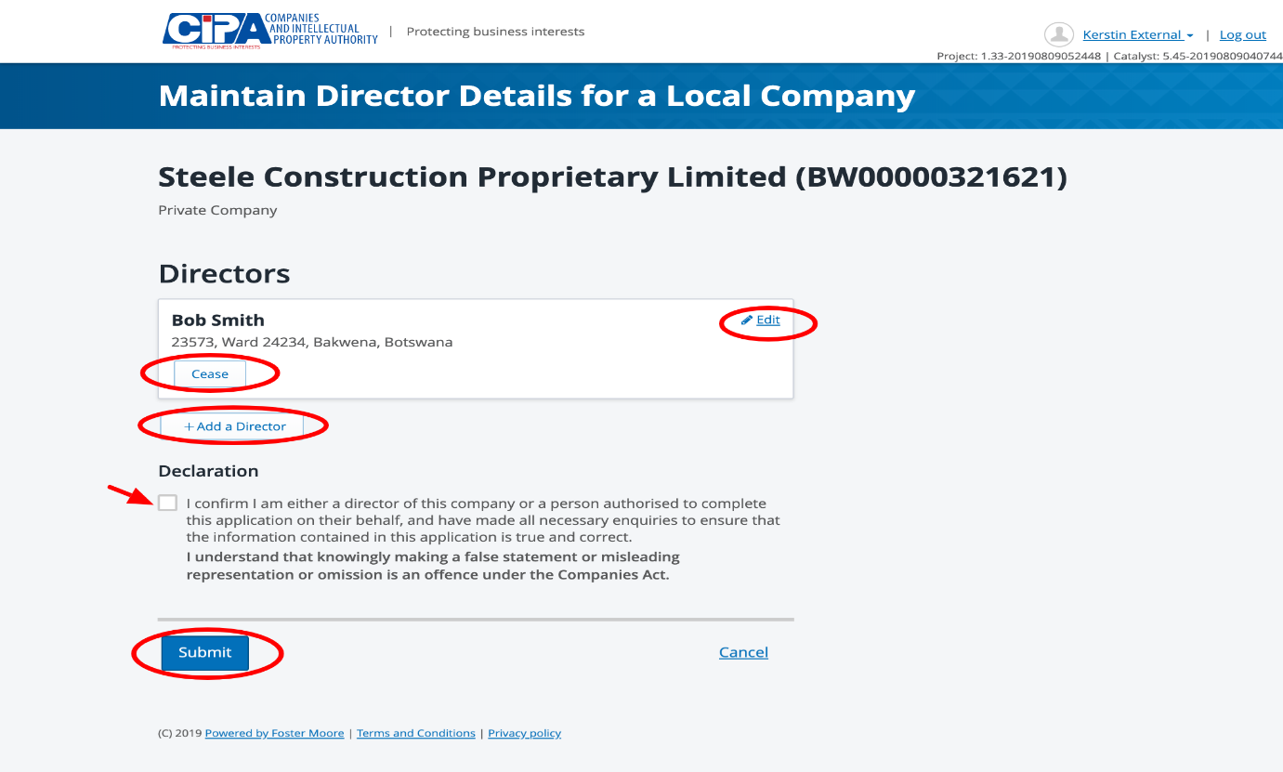
- Tick the declaration box to confirm that you are authorised to make the changes and submit.
- Ceasing Directors, updating contact and address information will automatically update the register.
- Adding new Directors will create a task to be reviewed by CIPA and a response will be given within 24 hours.

