HOW TO MAINTAIN SECRETARY DETAILS
This service allows changes to the Secretary details of a Company to be made. Existing Secretary's details can be updated, existing Secretaries can be ceased and new Secretaries can be appointed. Please note that only authorised users can make changes.
- Visit www.cipa.co.bw and log onto the OBRS.
- On your Portfolio on your dashboard click on the Company whose details you wish to change.
- Click on SECRETARIES (to the left).
- Click on EDIT DETAILS (to the right).
- Select MAINTAIN SECRETARY DETAILS FOR A LOCAL COMPANY.
- Read the BEFORE YOU BEGIN information and click CONTINUE.
- To edit the information of an existing Secretary click on EDIT. To remove an existing Secretary click on CEASE. To appoint a new Secretary, please click on INDIVIDUAL (to add a natural person as a secretary), or click on REGISTERED COMPANY (to add a registered company as a secretary) or click on OTHER (to add a firm as a secretary). When appointing a new Secretary, you will need to upload a consent form as well as a practicing certificate (one upload). Consent Forms can be found on the website under Quick Links/Forms and Downloads.
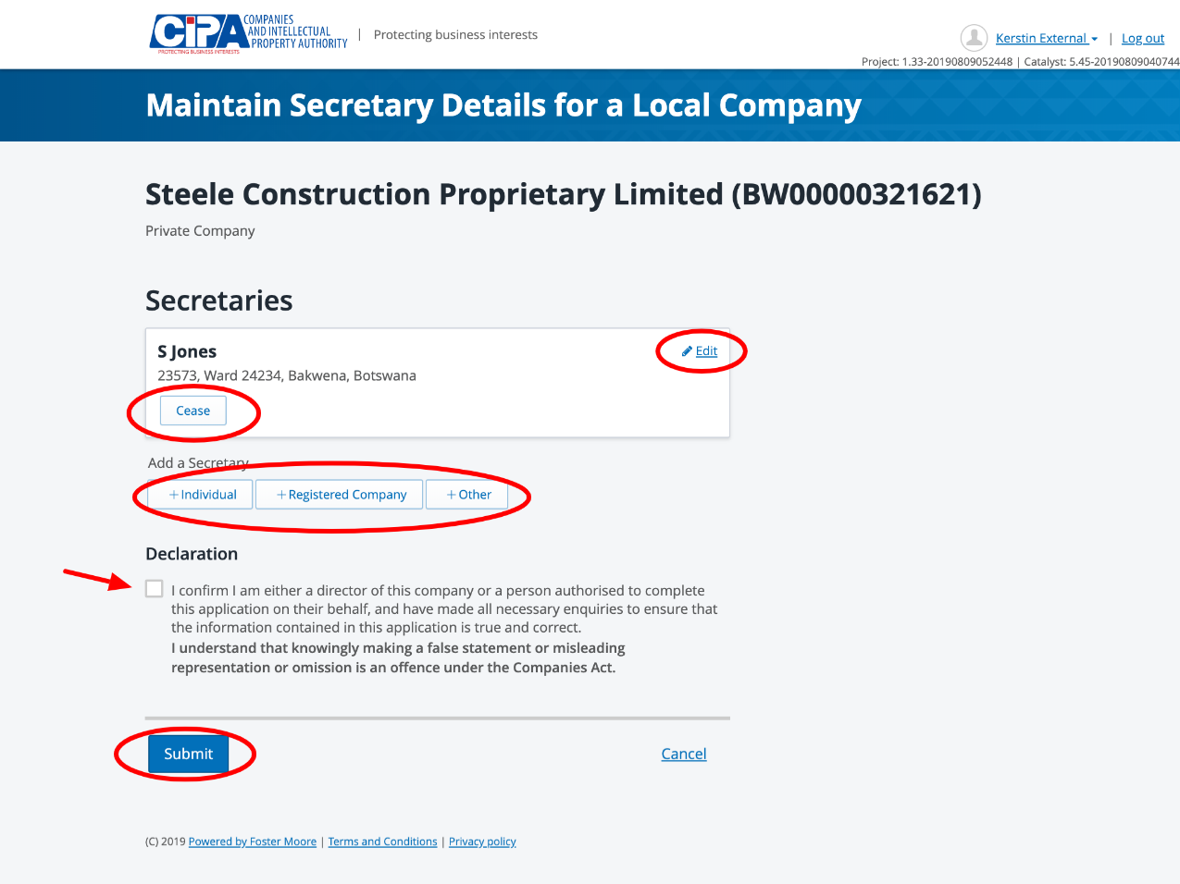

- Tick the declaration box to confirm that you are authorised to make the changes and submit.
- Ceasing a Secretary and editing contact and address information will automatically update the register.
- Appointing a new Secretary will create a task for CIPA to review and a response will be given within 24 hours.

