HOW TO MAINTAIN SHAREHOLDER DETAILS
This service allows changes to the Shareholder details of a Company to be made. The service allows you to change only the general information of existing shareholders, such as phone number, address, and beneficial ownership information. You are also allowed to change the name and ID details of shareholders where these have been legally changed, for example through marriage. This service does not allow you to cease/remove shareholders, add new shareholders, or change share allocations (to access these services you have to lodge a transfer of shares/issue of shares/acquisition or redemption of shares).
- Visit www.cipa.co.bw and log onto the OBRS.
- On your Portfolio on your dashboard click on the Company whose details you wish to change.
- Click on SHAREHOLDERS (to the left).
- Click on EDIT DETAILS (to the right).
- Select MAINTAIN SHAREHOLDER DETAILS FOR A LOCAL COMPANY.
- Read the BEFORE YOU BEGIN information and click CONTINUE.
- To edit the information of an existing Shareholder click on EDIT.

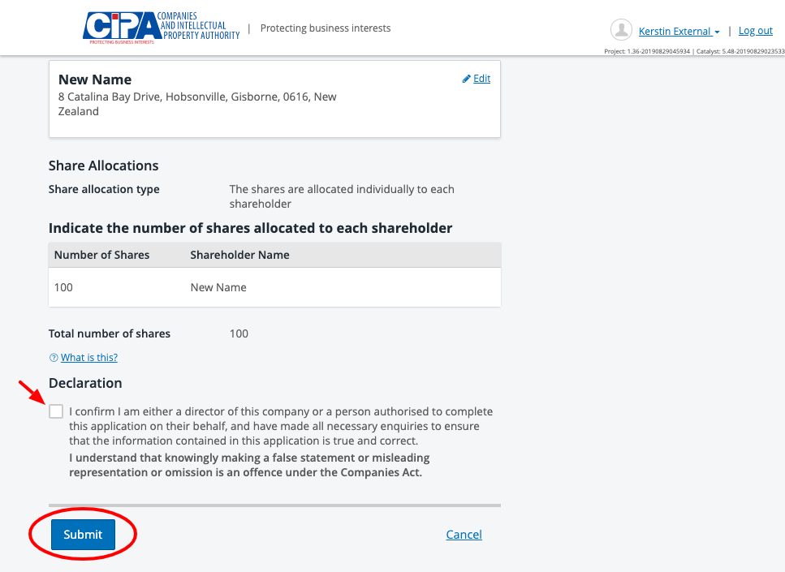

- Tick the declaration box to confirm that you are authorised to make the changes and submit.
- The submitted changes will automatically update the register.

