HOW TO MAINTAIN AUDITOR DETAILS
This service allows the Auditor details of a private or public company to be updated.

STEPS:
- Visit www.cipa.co.bw and log onto the OBRS.
- On your Portfolio on your dashboard click on the Company whose details you wish to change.
- If the Company has no existing Auditors, click the Filings and Maintenance menu and select Maintain Auditor Details for a Local Company
- If the Company already has existing Auditors, click on the Auditors tab on the left, and then click on the Edit Details button. Next, select Maintain Auditor Details from the menu.
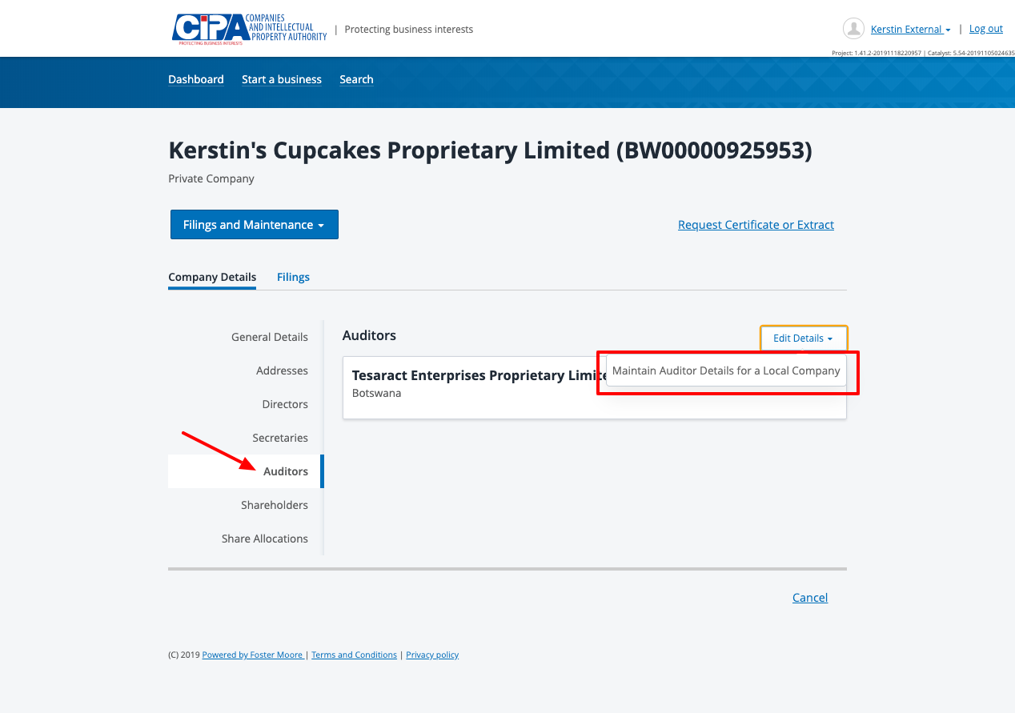

A: To Cease an Auditor, click the Cease button and enter a Ceased Date.
B: To change details for an existing Auditor, select the Edit button to display editable fields and Edit the details as required in the slide-out panel.
C: To add a new Auditor who is a person click the + Individual button.
D: To add a new Auditor who is a Registered Company Click the + Registered Company button and start typing the Company name and select the correct company.

- Make a payment
- Tick the declaration box to confirm that you are authorised to make the changes and submit.

What happens next?
- The service is sent for review by CIPA.
- You will receive a submission confirmation email and a response will be received within 24 hours.
SHOULD YOU HAVE ANY QUERIES, PLEASE EMAIL info@cipa.co.bw

