HOW TO MAINTAIN CLOSE COMPANY DETAILS
This service allows changes to be made to a registered close company. The following changes can be made using this service:
- Change of Company Name
- Upload/change constitution
- Change addresses
- Cease or add members
- Beneficial owner details
- Cease or add accounting officers
STEPS:
- Visit www.cipa.co.bw and log onto the OBRS.
- On your Portfolio on your dashboard click on the Company whose details you wish to change.
- Click on FILINGS AND MAINTENANCE.
- Click on Maintain Close Company Details.
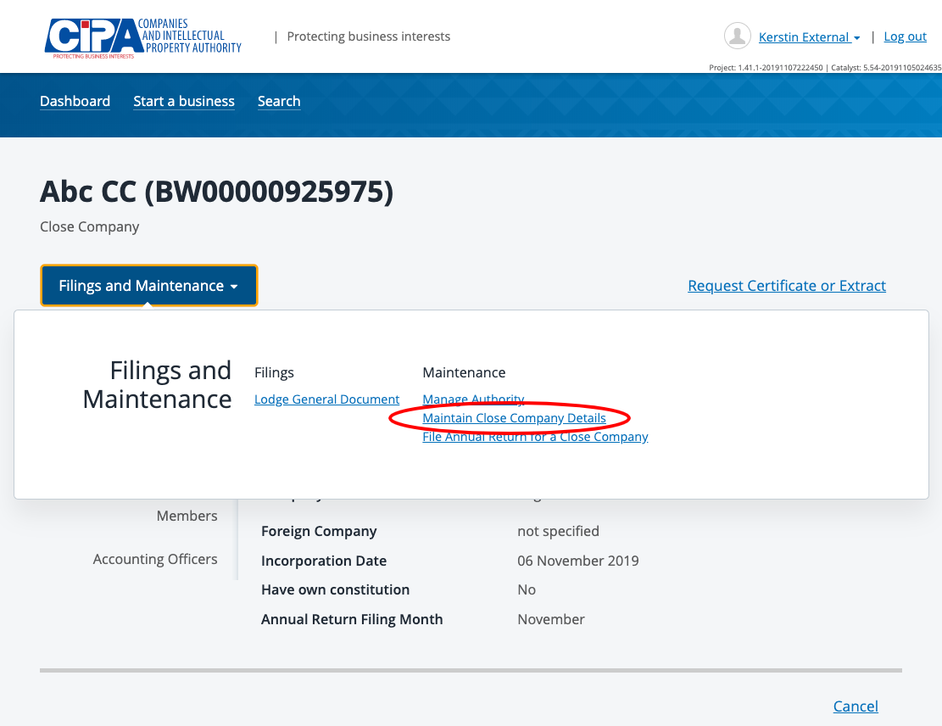
- Navigate to the section where you wish to make changes.
- Make changes as required.
- Make a payment
- Tick the declaration box to confirm that you are authorised to make the changes and submit.

What happens next?
- The service is sent for review by CIPA.
- You will receive a submission confirmation email and a response will be received within 24 hours.
SHOULD YOU HAVE ANY QUERIES, PLEASE EMAIL info@cipa.co.bw

