HOW TO MAINTAIN AN ETERNAL COMPANY
This service allows changes to be made to an external company. The following changes can be made using this service:
- Change of Company Name
- Amend constitution
- Change addresses
- Person authorised to accept service
- Cease or add Directors, Shareholders, or Auditors
- Share allocations
STEPS:
- Visit www.cipa.co.bw and log onto the OBRS.
- On your Portfolio on your dashboard click on the Company whose details you wish to change.
- Click on FILINGS AND MAINTENANCE.
- Click on Maintain AN EXTERNAL COMPANY.
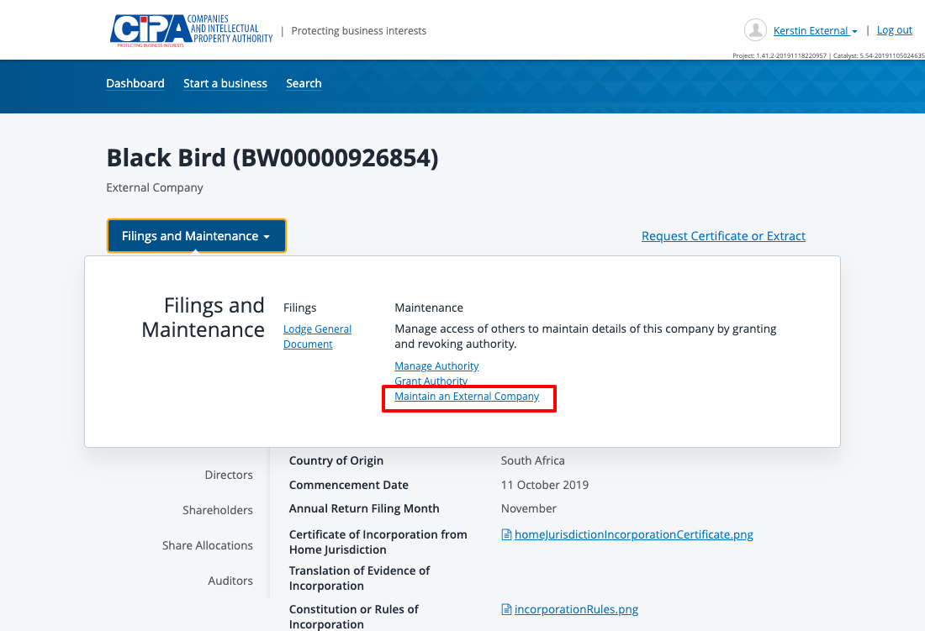
- Navigate to the section where you wish to make changes.
- Make changes as required.
- Tick the declaration box to confirm that you are authorised to make the changes and submit.
- Make a payment.

What happens next?
- The service is sent for review by CIPA.
- You will receive a submission confirmation email and a response will be received within 24 hours.
SHOULD YOU HAVE ANY QUERIES, PLEASE EMAIL info@cipa.co.bw

