This service allows an individual person or an organisation that doesn't already have an authority over an entity to request authority. Having authority will enable the individual or organisation to edit the corporate information and submit filings on behalf of the company.
- Go to www.cipa.co.bw and log onto the OBRS.
- Search for and click on the company that you wish to request authority over.
- Click on FILINGS AND MAINTENANCE.
- Click on REQUEST AUTHORITY.
- Select whether you are requesting Authority as a Director of the company or as an Agent of the company.
- If requesting Authority as a director, select your details from the drop-down menu. Your profile details must match those provided for the director of the company. (if you need to edit your profile in order to match the information on the company, please log in and click on your name to the top right). The system will automatically grant you Authority.
- If requesting Authority as an Agent, you will need to upload a Resolution from the company. Your request will create a task for CIPA to review, and a response will be given within 24 hours.
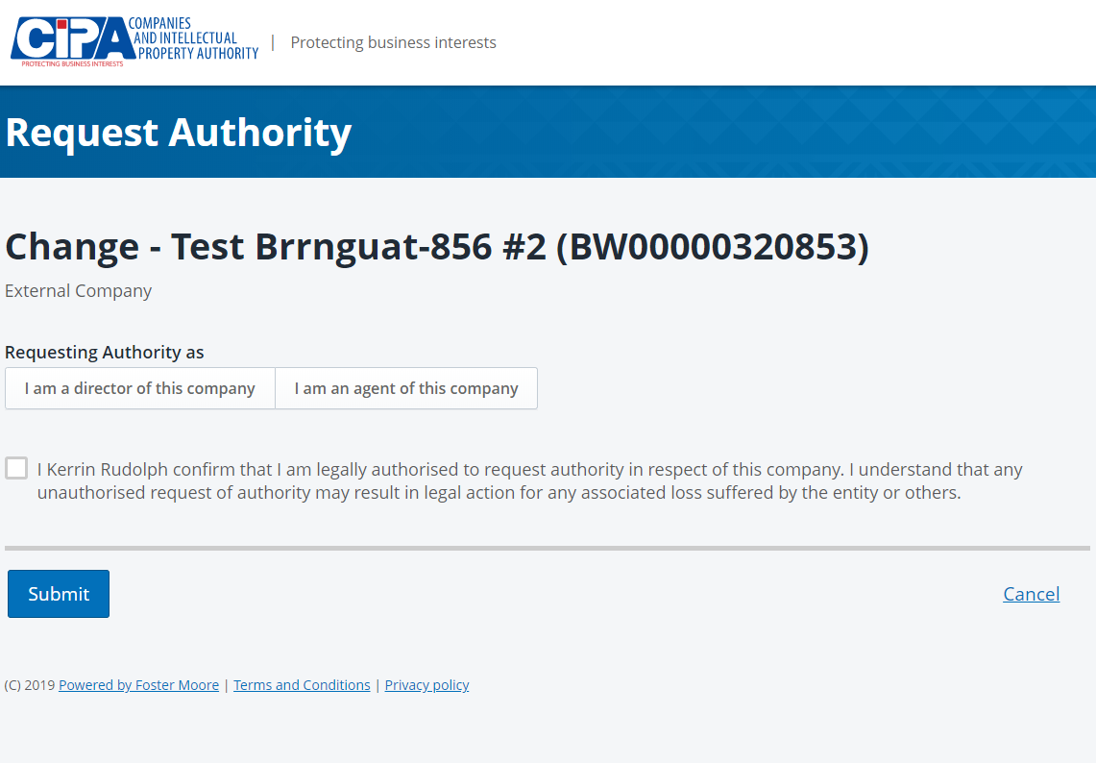

- Tick the declaration box to confirm that you are authorised to request Authority and click SUBMIT.

